ZLEDLighting Sales & Product Inquiry

We proudly provide sales and product assistance along with technical support.
Please provide us the information below and our sales team will get back to you.

I Need*

- ZLEDLighting Sales
- Product Support
- Check Inventory/Order
- Find a Distributor/Manufacturer Sales Representative
- Request Samples

Contact Information

(*AlMandatory fields)

First Name
Last Name
Email Address
Phone number
Prefered Method of Contact

Select an Option

What is Your Role*
- Electrical Distributor
- End User/Facility Owner/Homeowner
- Contractor/Installer
- Architect/Engineer/Installer
- ZLEDLighting Rep
- Other

Comments/Message Box
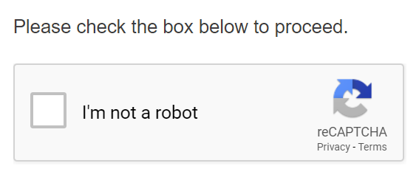


In a few minutes, you will receive a n automated email from us to confirm that we’ve received your request. If you do not receive this email, please check your spam folder. If our automated response is delivered to your spam folder, any future correspondence may appear there as well. If you do not receive the confirmation email we likely do not have your request form. Please feel free to resubmit or contact us at (800) 679-9243. Requests will be replied to no later than the next business day, including weekends and holidays.

*Required Fields to submit for with a Captcha to avoid spam.

